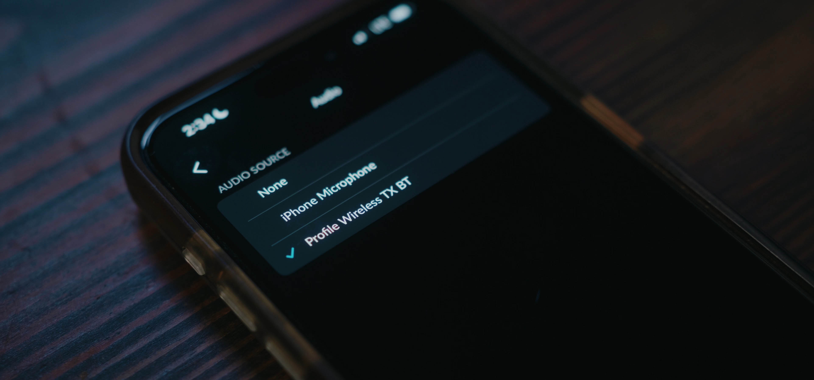

Sennheiser Profile Wireless now with Bluetooth connectivity
Latest firmware update has the all-in-one microphone system connect directly to compatible smartphones

Wedemark, April 13, 2026 – Great news for all owners of a one-channel or two-channel Profile Wireless set: the latest firmware update v 5.0.0 adds Bluetooth functionality to the compact microphone system. Creating a minimalist recording set-up, the clip-on mic can be directly paired with mobile phones, laptops or tablets that offer high-quality Bluetooth LE Audio (LC3 codec) or Bluetooth Classic.

“The free firmware update unlocks new possibilities, enabling creators to eliminate the receiver between the Profile Wireless clip-on mic and their mobile phone. This clears the smartphone connector for other usage and makes the set-up as compact as possible,” says product manager Hendrik Millauer.

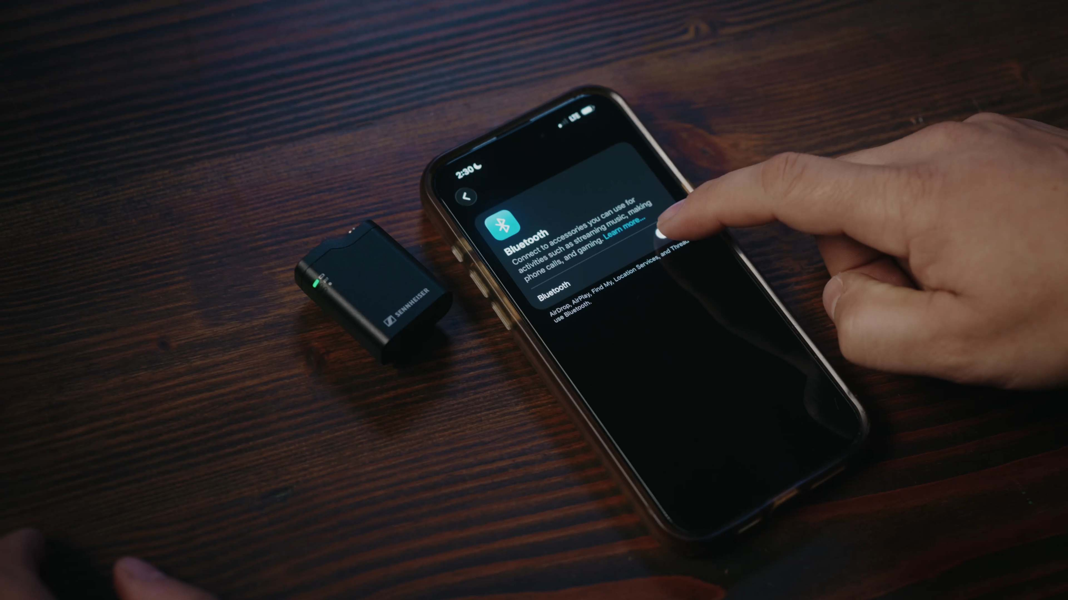 | With the latest firmware update v 5.0.0, the Profile Wireless clip-on mic can be directly paired with a mobile phone via Bluetooth LE Audio or Bluetooth Classic, depending on the model

As usual, the clip-on mic can be fitted with an external lavalier mic, creating a very unobtrusive miking solution. Connecting an external microphone will automatically disable the built-in mic.

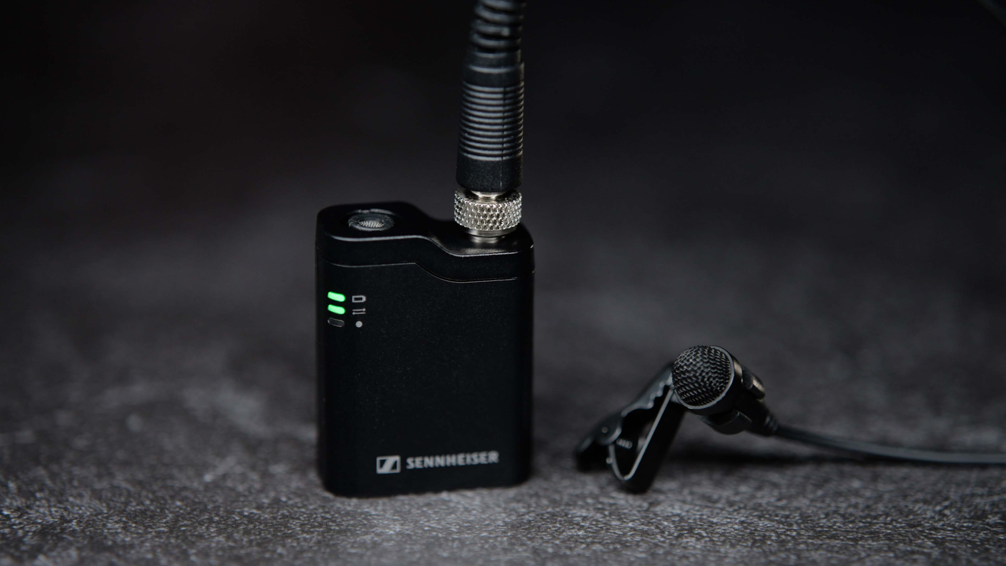 | The clip-on mic can also be used as a mini-transmitter for an unobtrusive external lavalier mic

A word on audio quality
“For highest audio quality, the Profile Wireless receiver is a must,” shares Millauer. “LE Audio with LC3 will provide creators with good audio quality and latency for any recording where ease of use and compactness are paramount. With a Bluetooth Classic connection, broad compatibility to smart devices and laptops is given but users will have to sacrifice some of the quality that the future-proof Bluetooth LE Audio offers today.”

The new firmware version v 5.0.0 can be downloaded from the Profile Wireless product page, while the online manual has been updated with information on the Bluetooth mode.

(Ends)

Bluetooth® is a registered trademark of Bluetooth SIG, Inc.

The high-resolution images accompanying this media release can be downloaded here.

About the Sennheiser brand
We live and breathe audio. We are driven by the passion to create audio solutions that make a difference. Building the future of audio and bringing remarkable sound experiences to our customers – this is what the Sennheiser brand has represented for 80 years. While professional audio solutions such as microphones, meeting solutions, streaming technologies and monitoring systems are part of the business of Sennheiser electronic SE & Co. KG, the business with consumer devices such as headphones, soundbars and speech-enhanced hearables is operated by Sonova Holding AG under the license of Sennheiser.

www.sennheiser.com
www.sennheiser-hearing.com

Pro Audio Press Contact
Stephanie Schmidt
stephanie.schmidt@sennheiser.com
+49 5130 600-1275

